PROJECT MANAGEMENT STRATEGY

JOURNEY PLANNER

horizontal line

**SUMMARY** **1**

Compare methodologies and choose one 2

Explain why we chose a certain methodology 2

Breaking down work to align with the water-scrum-fall methodology 3

Roles and responsibilities defined according to Prince2 and Agile 5

Challenges with Command and Control Leadership 6

References 6

## Compare methodologies and choose one

Waterfall is a traditional software development methodology that works sequentially. Waterfall aims to flow through each phase of the SDLC, ensuring one phase is 100% complete before moving on to the next, meaning that we only have to work through the SDLC once per project. This methodology requires the utmost research and preparation to ensure that everything runs smoothly and that no details are left out during each stage. Because of the extensive research that happens prior to a waterfall project, requirement time estimations tend to be more accurate. However, the linear progression through the SDLC phases makes it extremely difficult to work on new requirements that were left out during earlier stages. (Adobe Communications Team, 2022)

Scrum is an agile software development methodology with a focus on small-team collaboration. Scrum is a cyclic approach to the SDLC, with each run-through of the cycle being referred to as a sprint. Throughout the duration of a project, multiple sprints are completed, with new features/improvements being designed, built, and tested during each sprint. Because of Scrum's cyclic approach to software development, unexpected requirements can be added to the plan for the next sprint. This means that Scrum is much more agile than Waterfall and would be better suited as a methodology in an environment with lots of change. (Scrum.org, n.d.)

Water-Scrum-Fall is a methodology that combines the best elements of both Waterfall and Scrum. The combination consists of the strong beginning of Waterfall, meaning that a vast amount of research and requirements gathering is conducted before moving onto the cyclic, team-based approach used in Scrum. The Scrum team will have a solid, time-driven plan with a highly detailed roadmap they can stick to throughout the project duration. (Cloud Coach, 2021)

We have decided that the Water-Scrum-Fall will be best suited for this project.

## Explain why we chose a certain methodology

During the production of the South Yorkshire Journey Planner, we will use the Water-Scrum-Fall methodology.

During the planning phase, we considered the requirements and realised we needed a somewhat agile approach regardless of our methodology. Initially, there were risks associated with the unclear scope of the project and vague requirements. To mitigate these risks, we took an iterative approach by requesting feedback from the client at every stage of development. A clear understanding of the requirements led to a clear understanding of project direction, timelines, and budgets. Adopting the Water-Scrum-Fall methodology helps us define the upfront work.

In the middle of the journey planner development, Scrum will be introduced, ultimately assisting in software development. Scrum is designed to simplify teams' working practices, roles, and principles. Testers, developers, and business analysts will work together to complete the journey planner throughout the development process. Within each sprint, testing will occur so feedback and corrections can be applied as quickly as possible. Understanding and supporting change using the Water-Scrum-Fall methodology will enable the team to work better together, leading to a better application.

Our conclusion from this methodology will facilitate rapid feedback from customers during the development of this application. It will be necessary for the operations and development teams to cross-functionally work together when the application is released. We will evaluate the software release process every sprint to determine what needs to be improved. As part of each sprint week, we will also conduct data migration, security testing, and performance testing. In addition to gathering more rapid feedback for the team, these tests will also allow us to automate these processes much more.

Overall, we have chosen the Water-Scrum-Fall methodology because we believe it will help create a successful application in a robust, flexible process that will keep evolving and adapting. As part of the methodology, other concerns will be addressed, such as operations and business change, all in an agile approach.

## Breaking down work to align with the water-scrum-fall methodology

***Where do we use a structured approach (Prince2)?***

When we mention Prince2, we think of a methodology based on different, individual approach phases. Each phase is started only after the preceding one has been completed, thus resulting in a structured and well-defined methodology.

The initial phase of the project management strategy is commonly planned to follow a Prince2 approach, which requires the tasks to be completed logically and sequentially. At the same time, the phase following the Development process (Agile approach) is considered to be, once again, a structured approach, as there is no longer a need to collaborate between teams on different aspects.

We start with the Project Management section, split into multiple subsections: Project Planning, Scope Management, Risk Log, and Quality Management. The reason why we require a structured approach to these elements is that we need to fully understand each phase before moving forward to designing the product.

As mentioned above, the last phase of the project management breakdown is a Prince2 approach as well. This is because the main aspects of the product/work breakdown have been covered, and it is no longer necessary to collaborate and divide tasks between teams. The following stages follow a structured approach: Deployment of the project, Product Sign Off, and lastly, Perfective maintenance.

***Where do we use the Agile approach?***

Agile Sprints are commonly used best practices when working in teams on complex projects. Given this, we have decided to use this approach during the Development of the Journey Planner. The phases that need to follow an agile approach are: Requirements Specification, Designing the product, Building the front-end/back-end/mapping solution, Conducting tests, and Implementing the system.

We use this approach during these specific development phases because we need a way to provide/obtain feedback during team meetings regarding certain aspects of the implementation and follow different milestones that can be presented to the stakeholders.

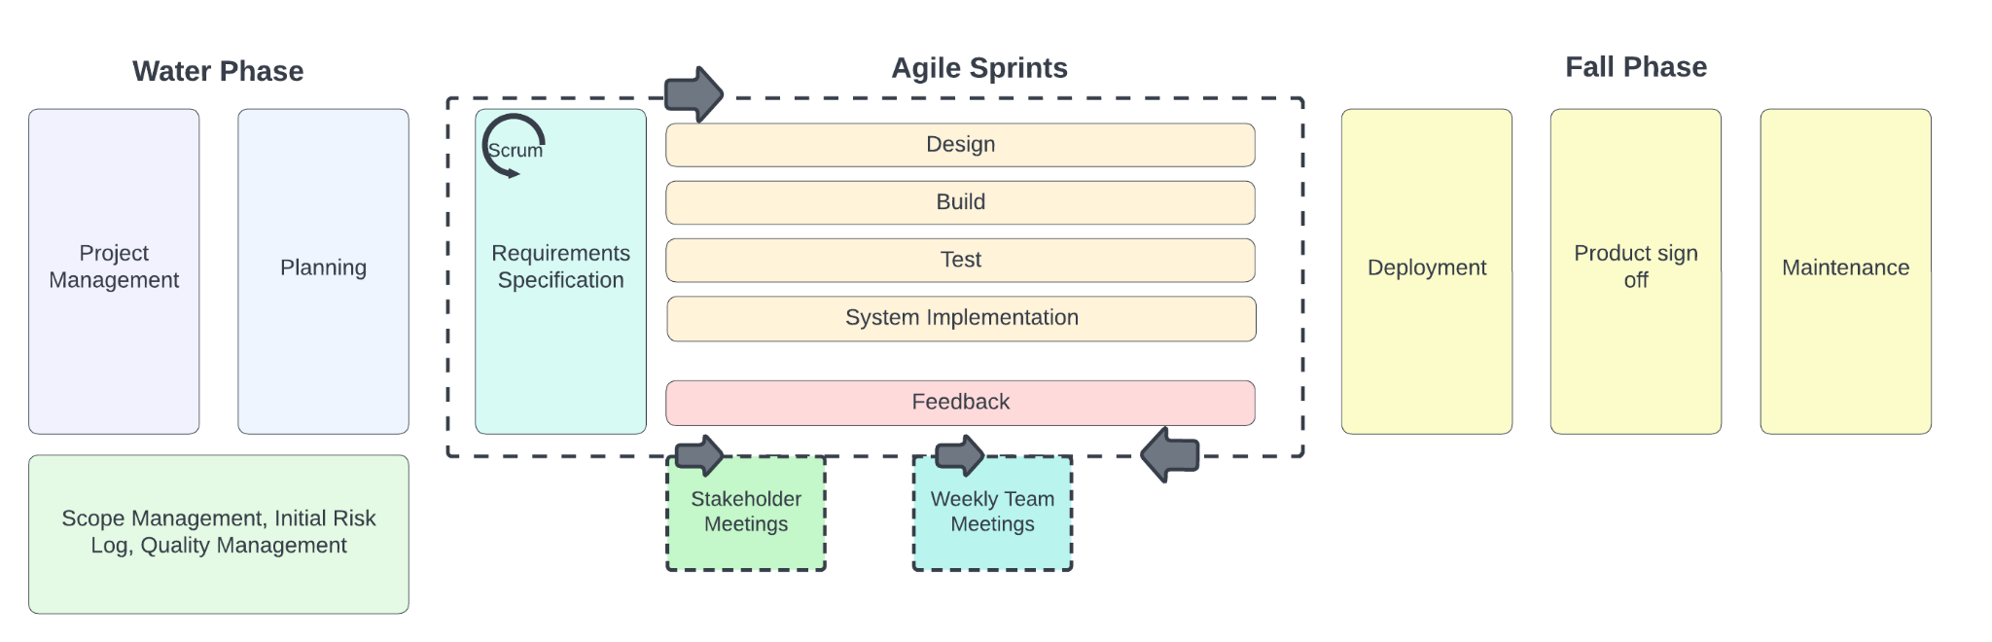

## Roles and responsibilities defined according to Prince2 and Agile

**Customer**

This is the individual that provides the funding for the project and has been commissioned for its creation. They ensure that the project is developed on time, on budget, and is what their company is asking for.

**Senior User**

Most of the time, the Senior User is a representative of the company for which the project is being created. They will need to talk to the client and be much more hands-on. This user will give feedback to the company and will often be the deliverer of any information.

**Senior Supplier**

The Senior Supplier will be the most experienced of Prince2 in the company and will use this experience to provide information about the project to the company about its chances of success and ensure that the project is on track.

**The Project Manager**

The Project Manager is the head of the project and will make the decisions for the project, such as the project’s team, budget standards, and the timescale. This job is essential as the entire project will be under his supervision.

**The Team Manager**

This role manages day-to-day activities, manages the team, and enforces the constraints during development that the Project Manager has put in place. On each project, there could be more than one or more of these roles assigned depending on the project size.

**Change Authority**

This role is the authority on the specification of the project. They will decide to change the specification, and it will often be filled by the project manager.

**Project Assurance**

Project Assurance is a role that must not be fulfilled by anyone that has a current role as it requires an independent and non biassed view of the project. This person’s full responsibility is to ensure the project remains on track.

## Challenges with Command and Control Leadership

The goals need to be clear to those around them. If it doesn’t, it can go astray very quickly as it will begin to quickly lead to mistakes being made due to confusion of goals. However, when this type of leadership is enforced, it can come with issues. People often feel micromanaged while working on a project, completely negating creativity and flexibility. Overall, the Command and Control Leadership style often leads to a fault because there is very little middle ground that provides team satisfaction and efficiency.

## References

Adobe Communications Team. (2022, March 18). *Waterfall Methodology*. Adobe Experience Cloud. Retrieved November 24, 2022, from https://business.adobe.com/blog/basics/waterfall

Archer, S., & Kaufman, C. (2013, October 29). *Accelerating outcomes with a hybrid approach within a waterfall environment*. PMI. Retrieved November 23, 2022, from https://www.pmi.org/learning/library/outcomes-hybrid-approach-waterfall-environment-5839

Cloud Coach. (2021, October 7). *A Guide to Water-Scrum-Fall Project Management*. Cloud Coach. Retrieved November 24, 2022, from https://cloudcoach.com/blog/a-guide-to-water-scrum-fall-project-management/

Scrum.org. (n.d.). *What is Scrum?* Scrum.org. Retrieved November 24, 2022, from https://www.scrum.org/resources/what-is-scrum